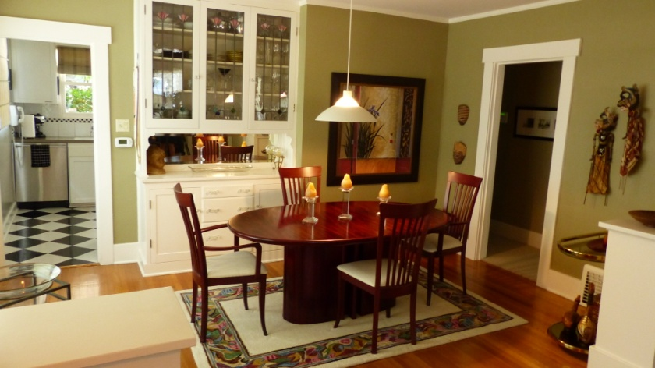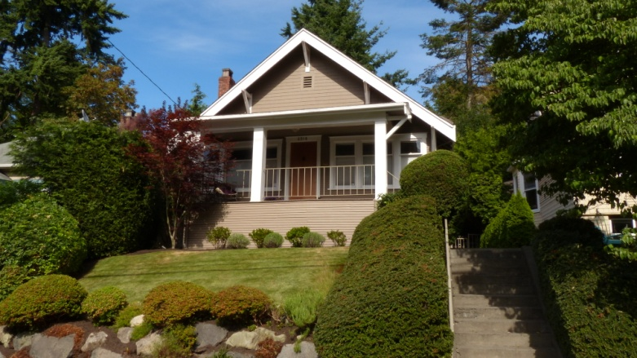

**Meticulously Maintained**

**1921 Queen Anne Craftsman**

|  |  |  |  |  |  |
| --- | --- | --- | --- | --- | --- |
|  | |  | | --- | |  | |  | |  | | This is the home you've been waiting for! Classic 3+ bedroom 2 bath home with alley access and rare 2 car garage plus a carport! Original built in china cabinet and book shelves. Covered deck and sunny patio off kitchen. Remodeled master bath and kitchen by award winning designer. All new stainless appliances. Mature landscaping with sprinkler system and outdoor lighting. Take the short walk to Queen Anne Ave for dining and shopping. | |

* Swedish finished hardwoods and new carpet
* Asian inspired master bath with heated floors
* European spa style second bath with jetted tub
* Brick fireplace with chimney recently tuck pointed and waterproofed with a lifetime guarantee
* Foundation earthquake retrofitted
* French drains and basement waterproofing with a lifetime guarantee
* Newly painted exterior and interior
* Newer hot water heater
* Alarm system
* Gas furnace with air conditioning
* Rocking chair front porch
* Custom designed roman shades
* All appliances and window coverings included

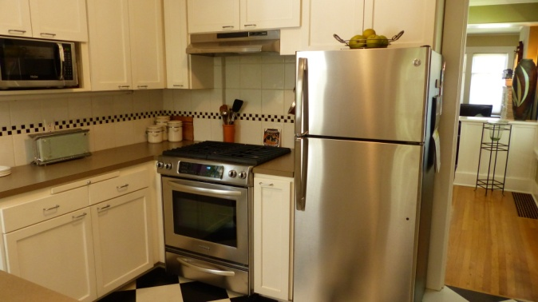

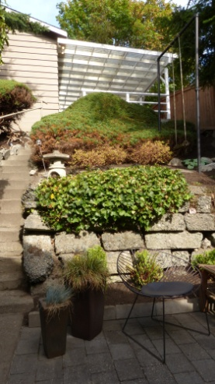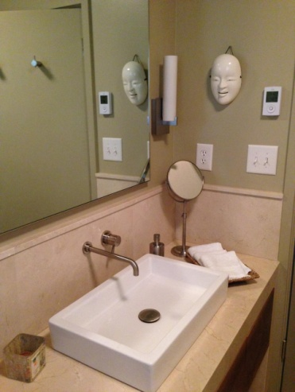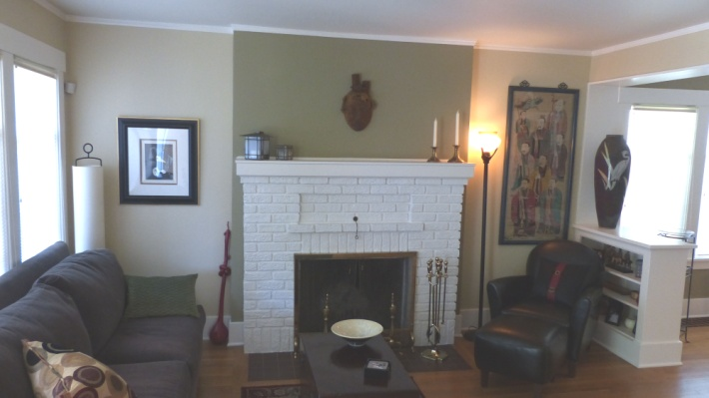

**2518 3rd Ave. W., Seattle, WA 98119**

**$795,000**

**MLS 816386**

**Alexis Pontikis**

**206-799-8820**

RSVP Real Estate Inc.